PHASE 6 – PROJECT TESTING
Project Title
Streamlining IT Procurement: Automating Standard Laptop Orders with Flow Designer
1. Introduction
The Project Testing Phase focuses on verifying whether the implemented Standard Laptop Procurement Automation works correctly in ServiceNow. Testing is performed to ensure that the Standard Laptop request is submitted successfully, approval is processed, the Flow is triggered, and a Catalog Task is automatically created and assigned to the Hardware group.
2. Testing Objectives
The main objectives of testing are:
- To verify that the Standard Laptop catalog item is accessible.
- To verify that a Standard Laptop request can be submitted successfully.
- To verify that the request is approved correctly.
- To verify that the Service Catalog trigger starts the Flow.
- To verify that a Catalog Task is created automatically.
- To verify the Short Description and Description.
- To verify that the task is assigned to the Hardware group.
- To verify the complete workflow from request submission to task creation.

3. Test Environment
The testing was performed using the following environment:
Component | Details
Platform | ServiceNow
Automation Tool | Flow Designer
Service Module | Service Catalog
Catalog Item | Standard Laptop
Trigger | Service Catalog
Action | Create Catalog Task
Assignment Group | Hardware
Browser | Web Browser
Internet | Required

4. Test Cases
The following test cases were prepared to verify the functionality of the project.
Test Case ID | Test Scenario | Expected Result
TC01 | Open Standard Laptop catalog item | Catalog item opens successfully
TC02 | Submit Standard Laptop request | Request is created successfully
TC03 | Verify Requested Item | Requested Item is generated
TC04 | Approve the request | Request status becomes Approved
TC05 | Verify Flow execution | Flow starts successfully
TC06 | Verify Catalog Task creation | Catalog Task is created automatically
TC07 | Verify Short Description | Displays “Laptop need to be Configured”
TC08 | Verify Description | Displays “Laptop need to be Configured”
TC09 | Verify Assignment Group | Task is assigned to Hardware
TC10 | Verify complete workflow | End-to-end process works successfully

5. Test Case 1 – Standard Laptop Request
The Standard Laptop catalog item was opened from the Service Catalog.
The catalog item was checked to ensure that it was available for users to submit a request.
Expected Result:
The Standard Laptop catalog item should open successfully.
Actual Result:
The Standard Laptop catalog item opened successfully.
Status: Pass

Standard Laptop Catalog Item
Standard Laptop page before clicking Order Now.
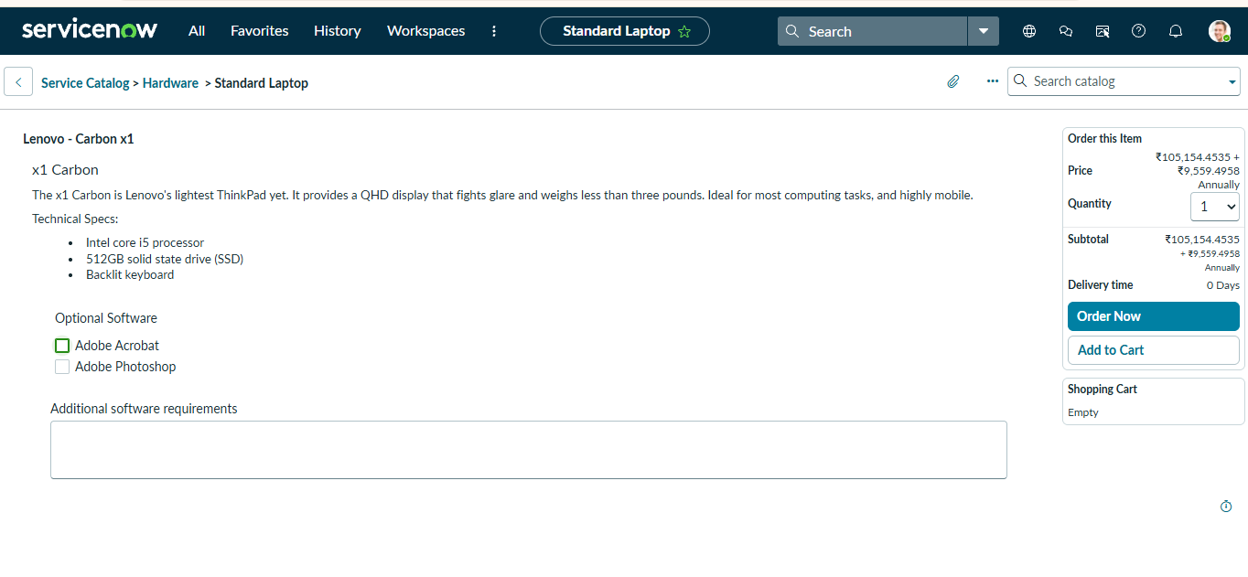

6. Test Case 2 – Request Submission
A Standard Laptop request was submitted through the Service Catalog by selecting Order Now.
After submission, ServiceNow generated a request number and a Requested Item.
Expected Result:
A new request should be created successfully.
Actual Result:
The request was created successfully with a Request Number.
Status: Pass

Standard Laptop Request Submitted
Request Number / submitted request page.
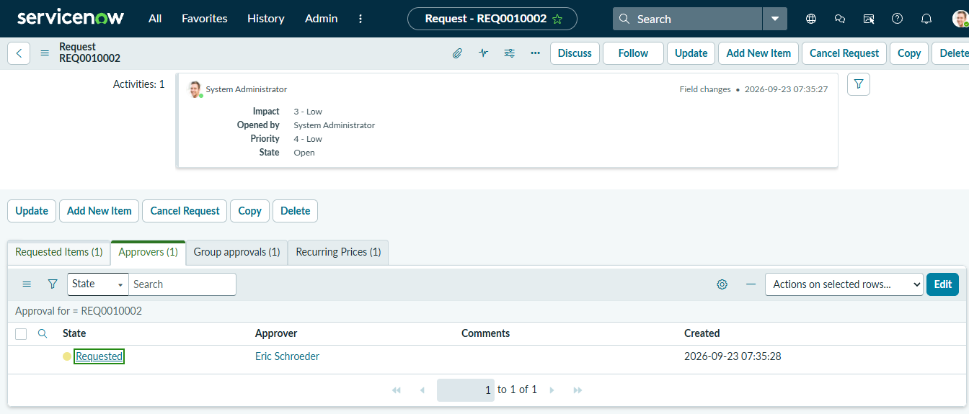

7. Test Case 3 – Request Approval
The submitted request was opened and the approval section was verified. The request was approved to allow the automation process to continue.
Expected Result:
The request should be approved successfully.
Actual Result:
The request was approved successfully.
Status: Pass

Approved Standard Laptop Request
Approvers section showing the approved status.
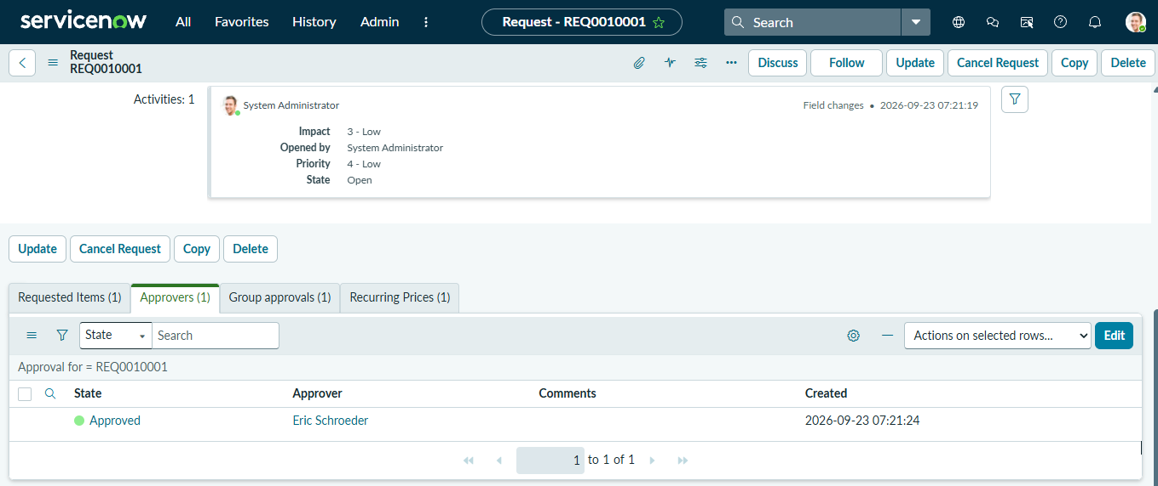
8. Test Case 4 – Flow Execution
After the request was approved, the configured Standard laptop task Flow was checked in Flow Designer.
The Service Catalog trigger was verified to ensure that the Flow was executed for the submitted request.
Expected Result:
The Flow should execute successfully after the required trigger condition is satisfied.
Actual Result:
The Flow executed successfully.
Status: Pass

Flow Execution
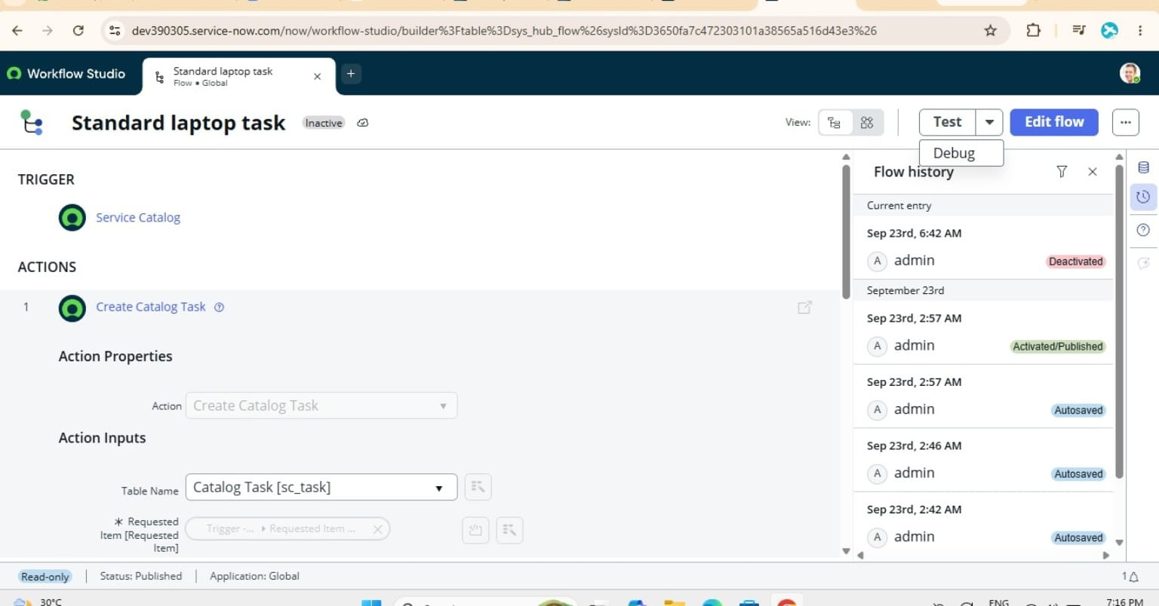
Flow execution/details showing the Flow ran for the request.

9. Test Case 5 – Catalog Task Creation
The Requested Item was checked after Flow execution. A new Catalog Task was automatically generated.
Expected Result:
A Catalog Task should be created automatically.
Actual Result:
The Catalog Task was created successfully.
Status: Pass

Created Catalog Task
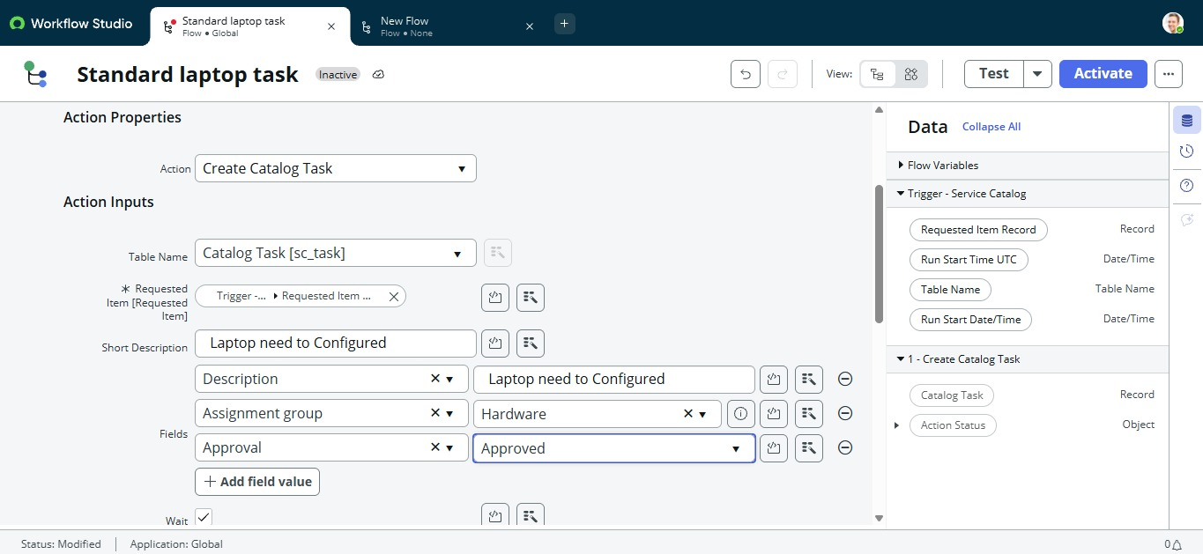
Catalog Tasks section showing the generated task.

10. Test Case 6 – Task Details Verification
The automatically created Catalog Task was opened and its details were verified.
The following values were checked:
- Short Description
- Description
- Assignment Group
- Task status
Expected Result:
The Catalog Task should contain the configured values.
Actual Result:
The task details matched the configured values.
Status: Pass

Catalog Task Details
Open the generated Catalog Task and show its details.
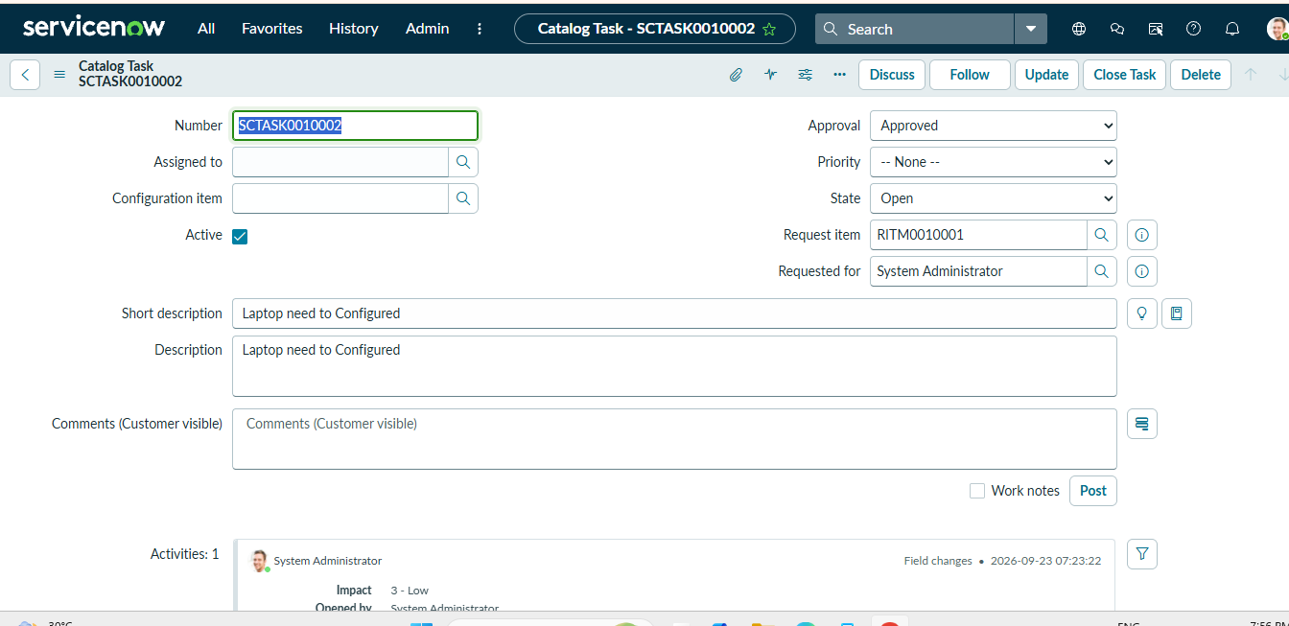

11. Test Case 7 – Hardware Assignment Verification
The Assignment Group of the generated Catalog Task was checked.
The task was expected to be assigned to the Hardware group.
Expected Result:
Assignment Group should be Hardware.
Actual Result:
The task was assigned to the Hardware group.
Status: Pass

Hardware Assignment
Catalog Task showing Assignment Group: Hardware.
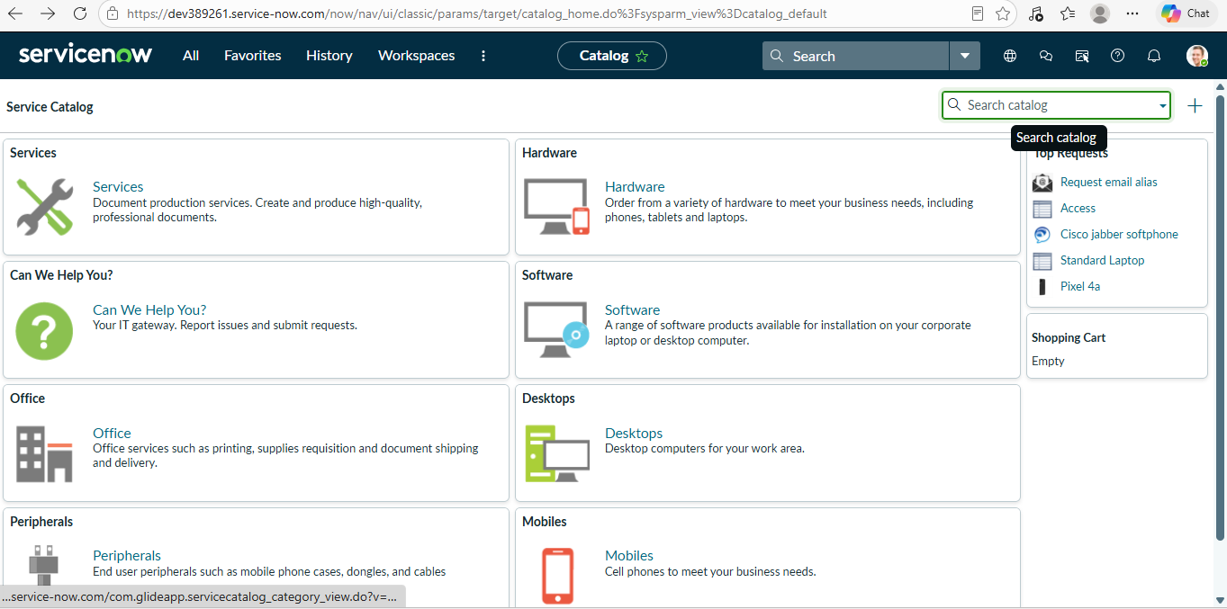

12. End-to-End Testing
The complete Standard Laptop procurement automation process was tested from request submission to automatic task creation.
The verified workflow was:
Standard Laptop Request → Approval → Service Catalog Trigger → Flow Execution → Catalog Task Creation → Hardware Assignment
The test confirmed that the configured Flow Designer automation works as expected and reduces the need for manual task creation and assignment.
Final End-to-End Result
Final generated Catalog Task showing the configured task details and Hardware assignment.

13. Test Result Summary
Test Case | Result
TC01 – Standard Laptop Access | Pass
TC02 – Request Submission | Pass
TC03 – Requested Item Verification | Pass
TC04 – Request Approval | Pass
TC05 – Flow Execution | Pass
TC06 – Catalog Task Creation | Pass
TC07 – Short Description | Pass
TC08 – Description | Pass
TC09 – Hardware Assignment | Pass
TC10 – End-to-End Testing | Pass

14. Conclusion
The testing phase verified the functionality of the Standard Laptop Procurement Automation implemented using ServiceNow Flow Designer. The Standard Laptop request was successfully submitted and approved, the Flow was triggered, and a Catalog Task was automatically created with the required description and assigned to the Hardware group.
The testing results confirm that the implemented workflow performs the intended automation process and reduces manual effort in standard laptop procurement.

